Exercise 2: Implementing the Factory Method Pattern
Aim
To implement the Factory Method Design Pattern in Java to create different types of documents such as Word, PDF and Excel without exposing the object creation logic to the client.
Project Name
FactoryMethodPatternExample
Source Code
1. Document.java
public interface Document {
void open();
}
2. WordDocument.java
public class WordDocument implements Document {

@Override
public void open() {
System.out.println("Word document created and opened.");
}
}
3. PdfDocument.java
public class PdfDocument implements Document {

@Override
public void open() {
System.out.println("PDF document created and opened.");
}
}
4. ExcelDocument.java
public class ExcelDocument implements Document {

@Override
public void open() {
System.out.println("Excel document created and opened.");
}
}
5. DocumentFactory.java
public abstract class DocumentFactory {

public abstract Document createDocument();

public void newDocument() {
Document doc = createDocument();
doc.open();
}
}
6. WordFactory.java
public class WordFactory extends DocumentFactory {

@Override
public Document createDocument() {
return new WordDocument();
}
}
7. PdfFactory.java
public class PdfFactory extends DocumentFactory {

@Override
public Document createDocument() {
return new PdfDocument();
}
}
8. ExcelFactory.java
public class ExcelFactory extends DocumentFactory {

@Override
public Document createDocument() {
return new ExcelDocument();
}
}
9. FactoryTest.java
public class FactoryTest {

public static void main(String[] args) {

DocumentFactory wordFactory = new WordFactory();
DocumentFactory pdfFactory = new PdfFactory();
DocumentFactory excelFactory = new ExcelFactory();

wordFactory.newDocument();
pdfFactory.newDocument();
excelFactory.newDocument();
}
}
Procedure
- Created a Java project named FactoryMethodPatternExample.
- Created a Document interface with an open() method.
- Created WordDocument, PdfDocument and ExcelDocument classes implementing the Document interface.
- Created an abstract class DocumentFactory containing the createDocument() method.
- Created WordFactory, PdfFactory and ExcelFactory classes extending DocumentFactory.
- Created a FactoryTest class to test the implementation.
- Compiled and executed the Java program successfully.

Output
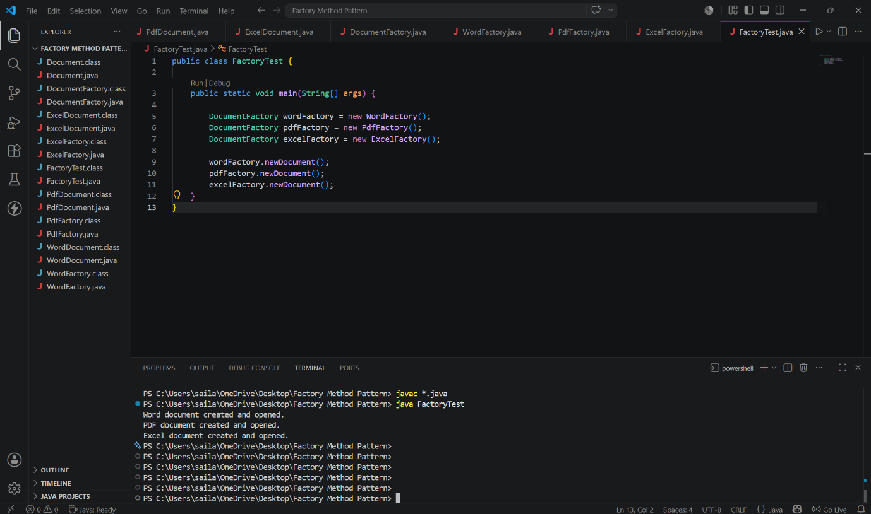

Conclusion
Thus, the Factory Method Design Pattern was successfully implemented in Java to create different document types efficiently and the program executed successfully.

